----PROJECT REPORT----

* College Course Enrollment Data Analysis..

Name – Kale Atharav keshav

Project Title –College Course Enrollment Data Analysis..
Date – 25 nov 2025
Technology – Language (Python)
Library -
- Pandas
- NumPy
- Matplotlib

1. Introduction
The Dataset contains important information related to students, such as their academic details and performance.
The main aim of this project is to organize, analyze, and extract meaningful insights from the data using Python and the Pandas library.
Through this project, we perform basic data analysis operations like data loading, data cleaning, data selection using loc and iloc, and simple statistical analysis.
This analysis helps in understanding student performance patterns, identifying trends, and supporting better academic decision-making.

2. Objective of the Project
The main objectives of this project are:
• To study and understand the given student dataset.
• To load and manage student data using Python Pandas library.
• To perform data selection and filtering using loc and iloc.
• To analyze student performance using basic data analysis techniques.
• To identify patterns and trends in student academic data.
• To improve data handling and analytical skills using Python.
• To present meaningful insights that support academic decision-making.

3. Dataset Description
The dataset used in this project contains 1000 records of Stident Data data.

Columns in Dataset:
• Student_ID
• Name
• Gender
• Age
• Course
• Year
• Attendance_Percentage
• Study_Hours_Per_Week
• Internal_Marks
• Final_Exam_Marks
• Result

Dataset Characteristics:
- Contains duplicate values
- Contains missing (NULL) values
- Realistic sales data for analysis practice

4 Key Insights of the Project (Student Dataset)
Students with higher attendance tend to score better marks.
An increase in study hours leads to improvement in final exam marks.
Students with regular attendance show a higher pass percentage.
There is a strong relationship between internal marks and final exam marks.
Students with fewer study hours generally score lower marks.
There is no significant performance difference between male and female students.
Course-wise analysis shows that some courses have better overall performance.
Students with low attendance fall into a high-risk category and need academic support.

5. Code

IMPORT LIBRARIES
import pandas as pd
Import seaborn as sns
import numpy as np
import matplotlib.pyplot as plt

Load Dataset
df = pd.read_csv("Student_Data.csv")
df.head()
df = pd.DataFrame(data)

DISPLAY DATA
print(df.head())

MATPLOTLIB (Basic Visualization)

Heatmap :-

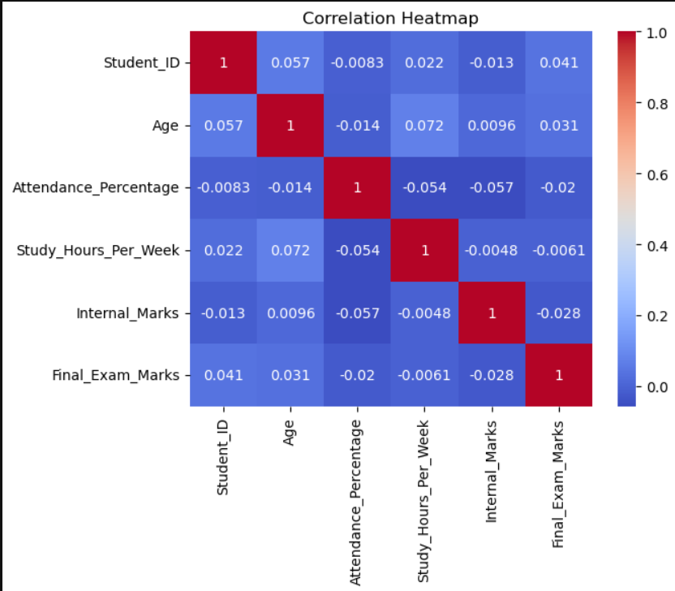

# . Bar Chart :-

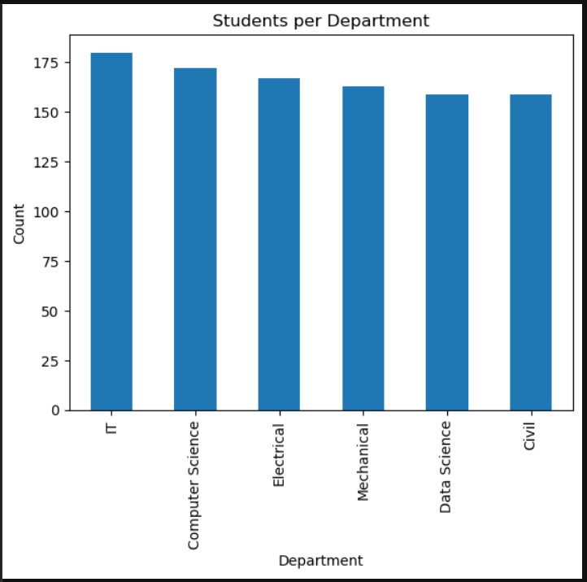

PIE CHART –Gender Couese Enrollment
df['Gender'].value_counts().plot(kind='pie', autopct='%1.1f%%')
plt.title("Gender Distribution")
plt.ylabel("")

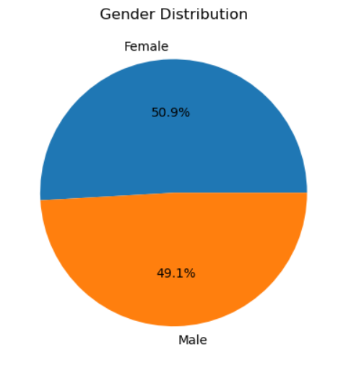

6. Data Analysis Process

6.1 Data Cleaning
- Checked missing values using isnull()
- Identified duplicate records using duplicated()
- Missing values were analyzed but not removed

7. Data Visualization
The following charts were used:
- Bar Chart – Student Per Depatment Enroll Course
- Heatmap Chart – Corelation Heatmap
- Pie Chart – Gender distribution Enrollment Course

9. Conclusion
This project analyzes student data using Python and Pandas.
It shows that students who study more and attend classes regularly score better marks.
Attendance plays an important role in student success.
Internal marks are closely related to final exam marks.
Overall, the project helps understand student performance easily.

10. References
- Python Documentation
- Pandas Official Guide
- Data Analysis Learning Resources

